## ST ALOYSIUS’ COLLEGE



## Year 10 Mathematics Stage 5.3

***Assessment 30th March 2017***

### Time allowed: 50 minutes

Name:

Teacher: ADA, PLU, MWA, IMO

Instructions:

* All necessary working is to be shown
* Approved calculators may be used.
* Marks may be deducted for careless or poorly arranged work.
* Answer in booklets provided.
* Begin each section in a new booklet. **TOTAL MARKS: 42**

**SECTION I** *10 marks for this section*

**Answers for this section are to be recorded on the separate answer sheet provided.**

1. The surface area of a rectangular prism of length 4 m, width 3 m and height 2 m is:

(A) 52 m2 (B) 24 m2

(C) 48 m2 (D) 81m2

**2.** Which of the following correctly shows 0.015783 with 3 significant figures?

(A) 0.02 (B) 0.016 (C) 0.0158 (D) 0.0157

**3.** Calculate the area of the shape (in m2).

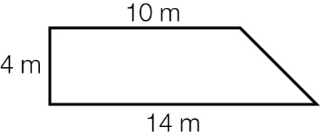

(A) 280 m2 (B) 560 m2

(C) 96 m2 (D) 48 m2

**4.** The letters of the word SCORE are written on separate cards.

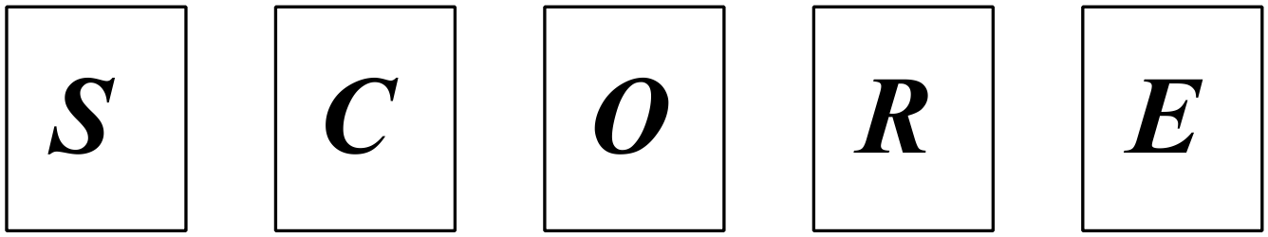

When 2 cards are drawn at random the total number of possible outcomes is 20.

Which statement is true?

1. The first card is drawn with replacement

1. The second card is drawn without replacement
2. The second card is drawn with replacement
3. The first card is drawn without replacement

**5.** The sides of a cube are 5 cm. Which of the following is an incorrect statement?

(A) The volume is 125 cm3

(B) The surface area is 150 cm2

(C) If the sides of the cube are doubled, the volume is increased by a factor of 4.

(D) If the sides of the cube are halved, then the surface area is decreased by a

factor of 4.

**6.** A solid is formed using a cylinder and a hemisphere as shown.

10cm

10cm

The volume of the solid, to the nearest cm3 is

(A) 417 cm3

(B) 1309 cm3

(C) 333 cm3

(D) 1047 cm3

**7.** The probability of event *A* or event *B* is given by



Which Venn Diagram represents this probability?



(A)

 (B)

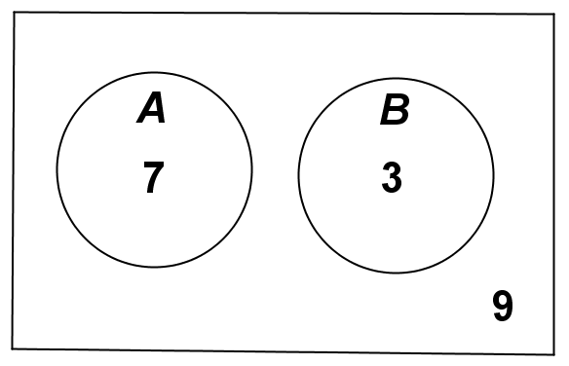

(C)

 (D)

**8.** Simplify=

(A) 8*p*6

(B) 8*p*18

(C) 4*p*18

(D) 4*p*6

**9.** 5 can be re written as;

1. −

(B) 

(C) 

(D) 

**10.** Written as an ordinary numeral  is:

(A) 

(B) 

(C) 

(D) 

**END OF SECTION 1**

**SECTION II** *20 marks for this section*

**Start a new booklet**

1. Write without negative indices.

(i)   **1**

(ii)  **2**

**2.** Convert  into a fraction. **1**

**3.** If  find *x.* **2**

**4.** Simplify ** **2**

**5.** Express  with a rational denominator. **2**

**6.** Simplify the following.

(i) **2**

(ii)  **3**

**7.** A square pyramid has a base with length 10 cm and a perpendicular height

of 6 cm.

*V*

*B*

*S*

*C*

(i) Find the length of the slant height *VS.* *(Answer in exact form.)* **1**

(ii) Find the total surface area of the pyramid. **3**

*(Answer to 2 decimal places.)*

(iii) Find the length of the edge from the vertex *V* to the corner *C*.

*(Answer in exact form.)* **1**

**SECTION III** *12 marks for this section*

**Start a new booklet**

**1.** Solve the following equation:  **2**

**2.** Simplify  **2**

**3.** If , find the values of *a* and *b*. **3**

**4.** Light travels at km/s. One light year is the distance that light travels in a **2**

year. (given that one year contains 365.25 days).

How many kilometres are in one light year? *(Answer in scientific notation)*

**5.** A sphere, cone and cylinder all have the same diameter. The height of the **3**

cylinder and cone are equal to their diameters.

Find the ratio of their volumes.

**END OF ASSESSMENT**